**Steps to test the application.**

1. Create a database.
2. Run the script file(CreateTable.sql) present in the folder “Documentation” to create Contacts table in the database that you created.
3. Change the connection string in appsettings.json file present in the Host folder of the solution.

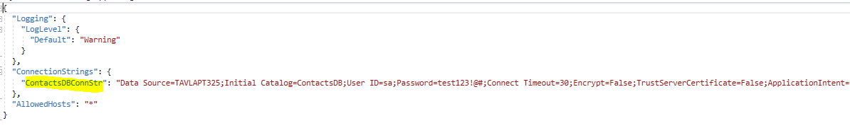

1. Provide the connection string of the database that you created.
2. Run the solution.
3. You may use the Visual Studio Code source file that I have provided(present in the documentation folder) to test the application.

To use Visual Studio Code to test the application, please follow the below steps:

1. Install Visual Studio Code editor.
2. Once Visual Studio Code is installed, kindly add the extension “Rest Client” to VS code. Please see the snapshot below:

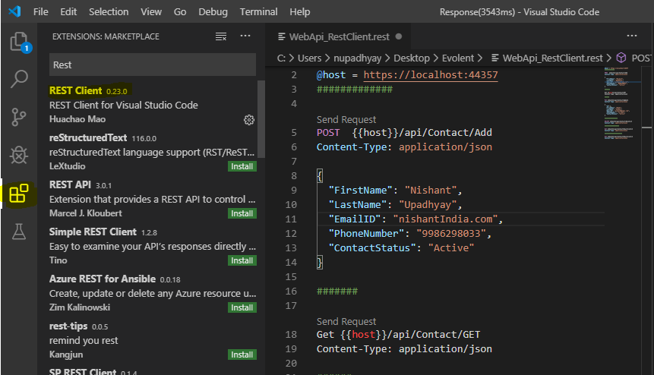

Change the host variable with the localhost address where the code is running on your system.

You may now be able to make rest calls to the api using the VS Code sample I have shared.